**Week4**

**29, July 2019 ~ 4, August2019**

**MyeongGeun(Matthew) Jo in UCSD**

WEEK 4..

Last week, I’;m just finish Sign-up and Sign-in in part. But, in this week I do so many things. Look at this picture what I do in this week.

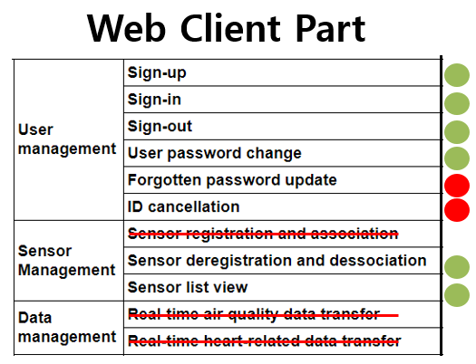

Red mark is not done. Red line is not need to implements in Web client. So many things do in this week. Server part is more do.

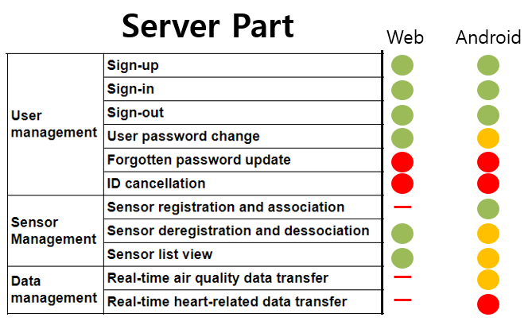

In Server part, at Last week, I finished sign-up. Sign-in was work, but not complete.

In this week, Sign-in/out/userpassword change/ sensor Deregistrate / sensor list view are complete. Only functionaly, not design.

Green sign is all clear, include client.

Yellow sign is, Server part is done, but Client is not done.

Red sign is, Server and client both are not done.

Communication with Server and Web Client is clear, but in Android Sensor deregistration and dissociation, real-time air quality data transfer

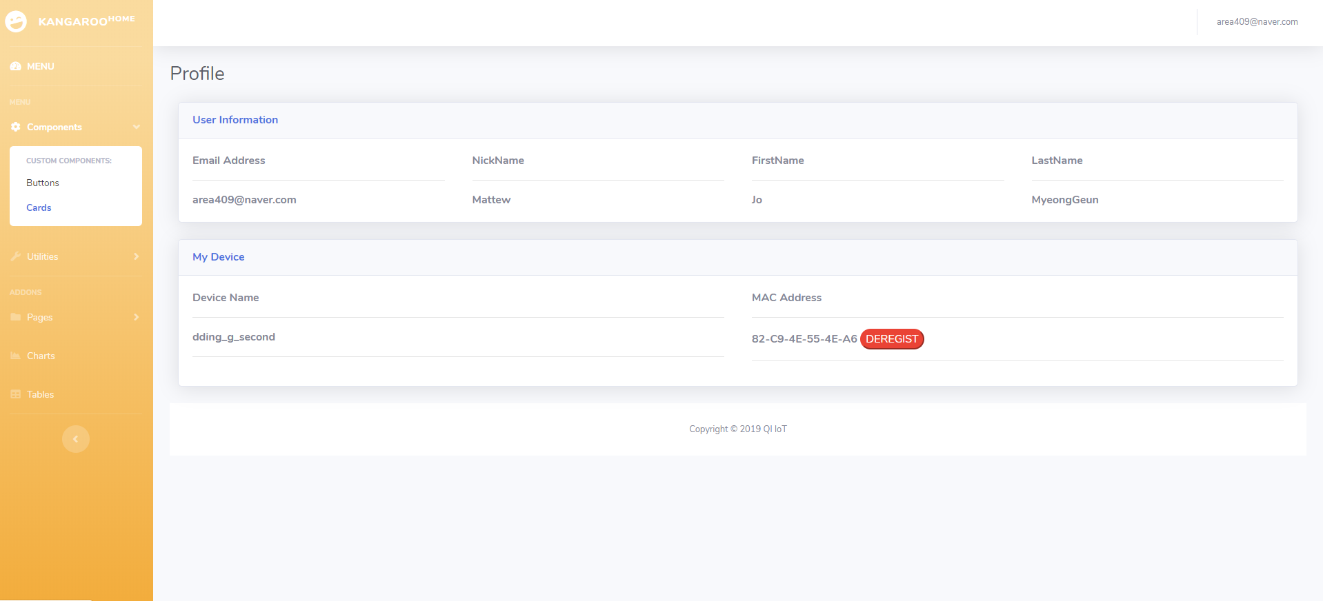

* User Profile page

In profile page, I show user data and device data. Device can deregister only in web client. If you want sensor registrate or send data, you can use application version. For implement deregistration, I should study jquery. It is first time to me. The point is many things are first time to me. It is really good part that I can study new in here.

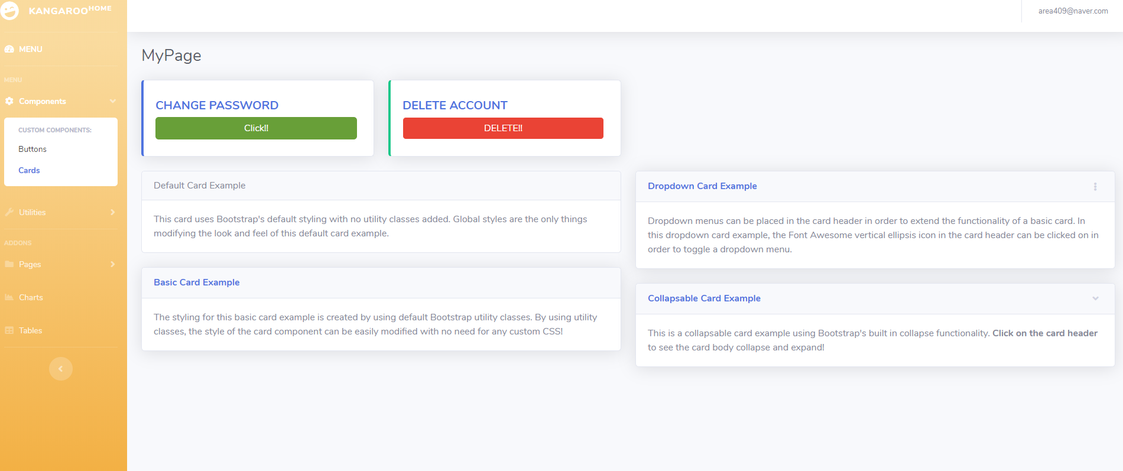

* MyPage
* 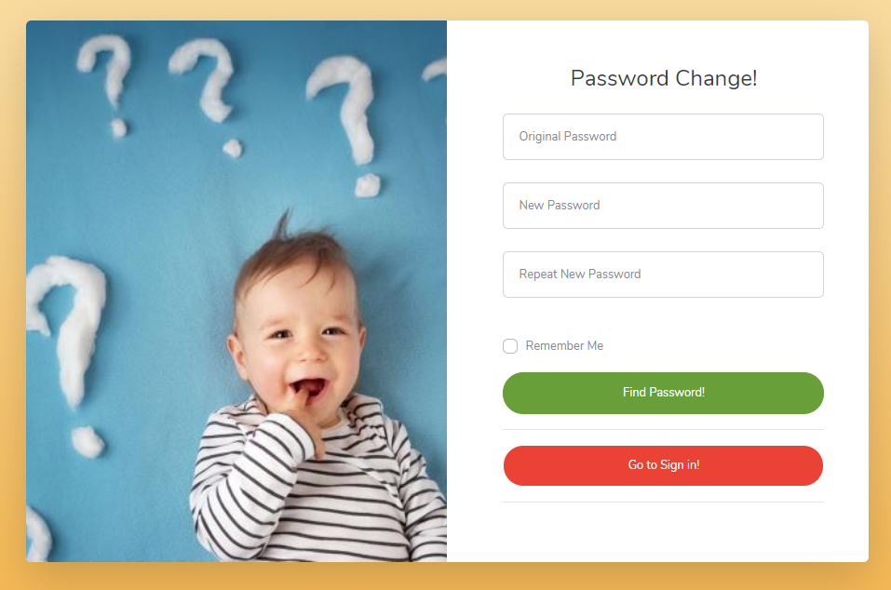

In Mypage, Users can change password and delete account. In now, Change password is implements but, DELETE account is not implements. User password change is not difficult. It is similar to sign-in/up. It just chack old password and update new password!

I should implements the other minimum require and optionally things. So I will report our project for last week.

I do my best always.

**MyeongGeun(Matthew) Jo in UCSD, 2019 QI summer project.**